**1.Host a Ubuntu Virtual Machine using Oracle VM Virtual Box. (5 marks)**

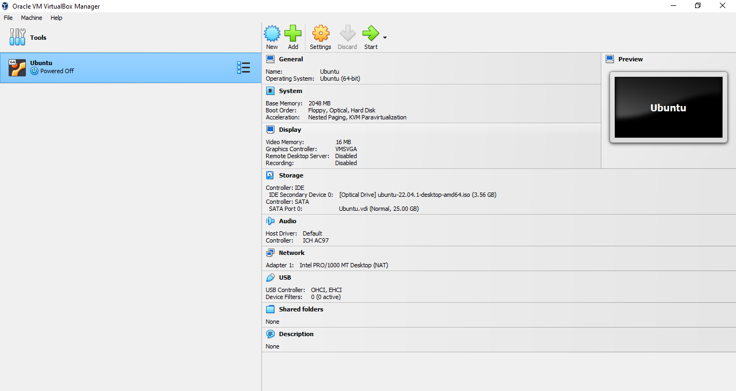

**2.Set up Visual Studio code on Ubuntu VM. (5 marks)**

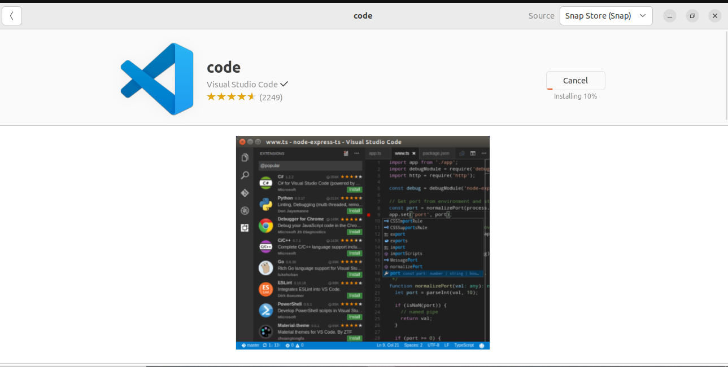

**3.Set up Python. (5 marks)**

1.sudo apt update

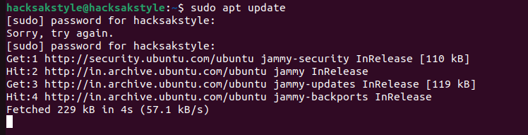

**2.**sudo apt install software-properties-common

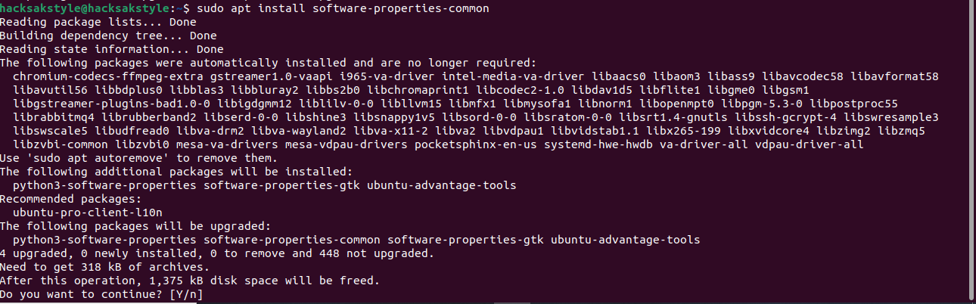

3.sudo add-apt-repository ppa:deadsnakes/ppa

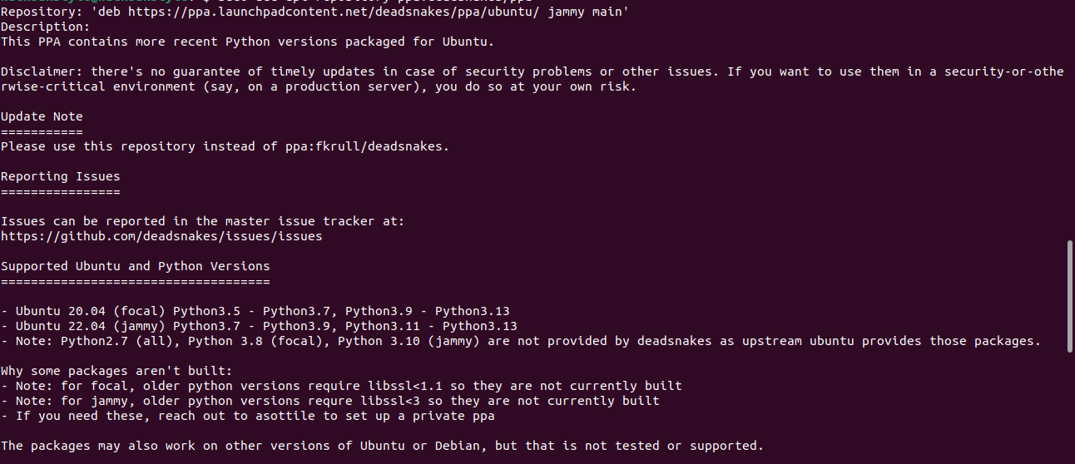

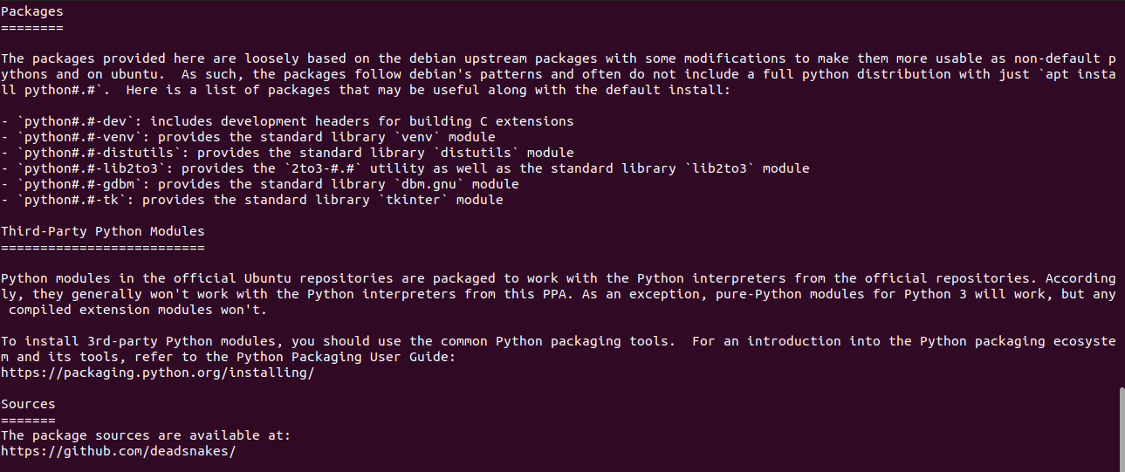

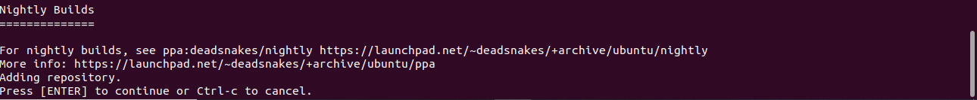

4.sudo apt install python3.10

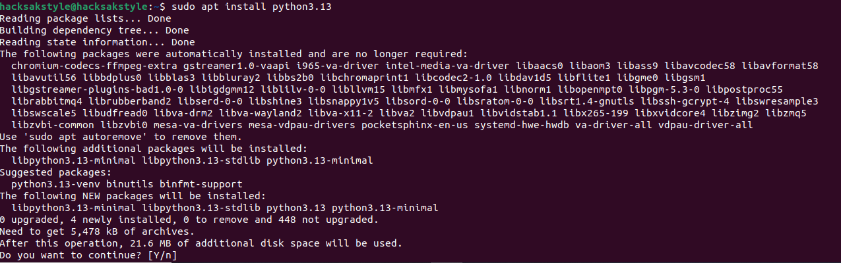

4.Clone this Github repository https://github.com/Vikas098766/Microservices.git(1 mark)

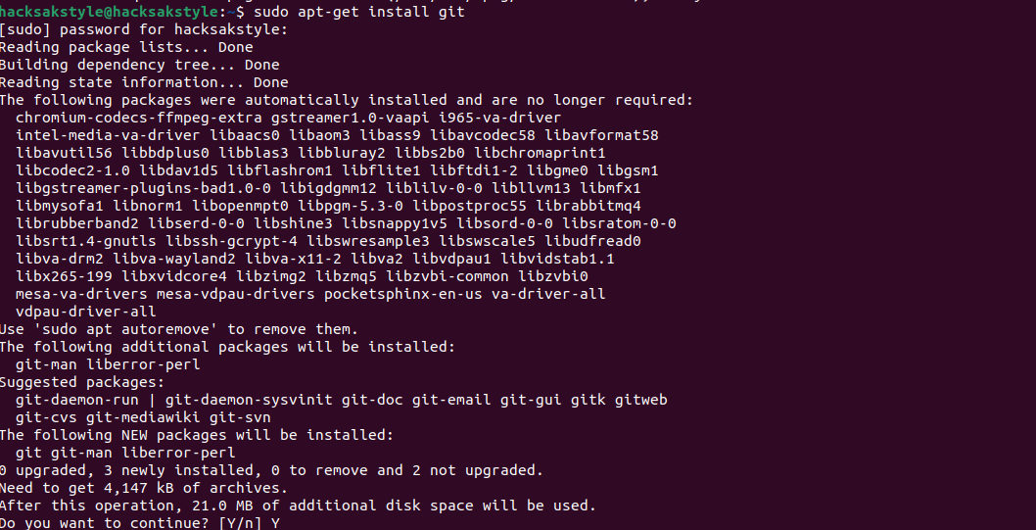

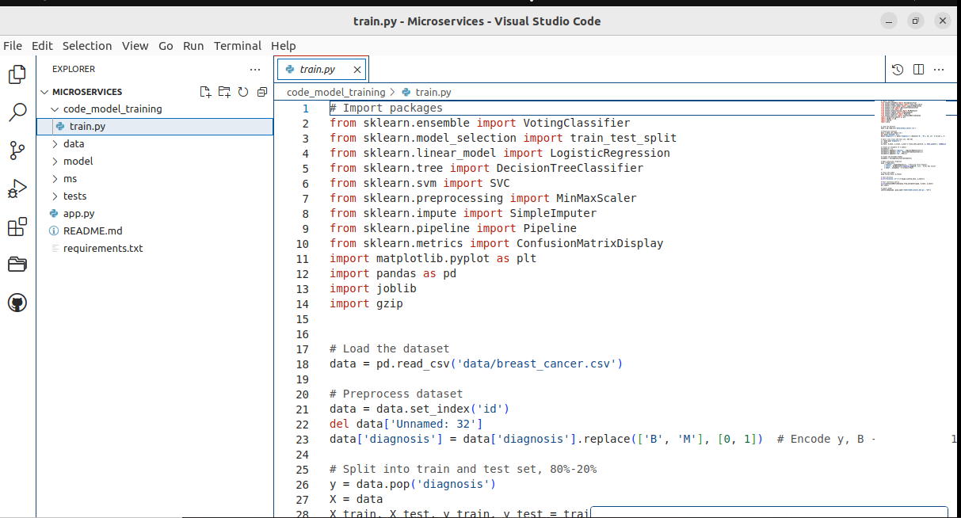

5.Create a Virtual Environment. (1 mark)



6.Install the dependencies from requirements.txt file. ( 1 mark)

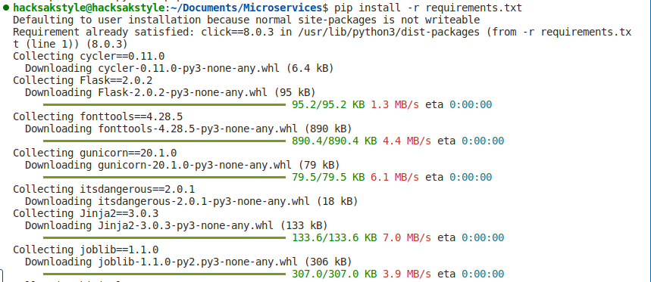

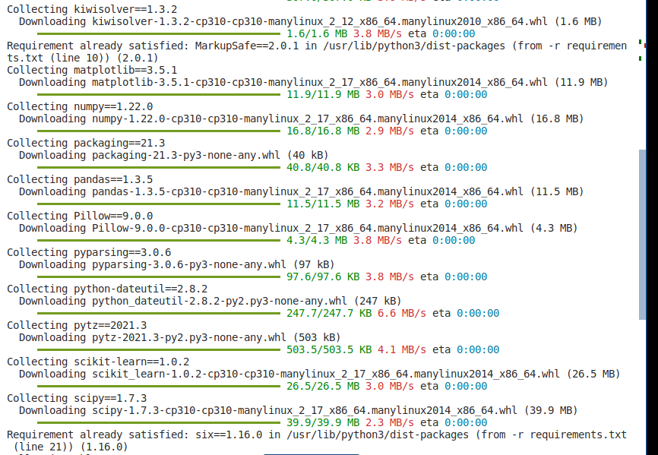

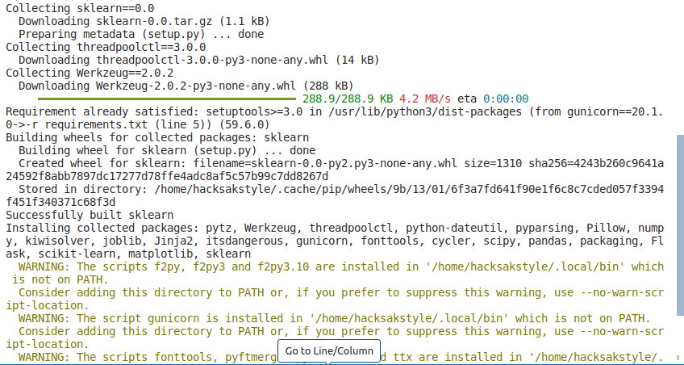

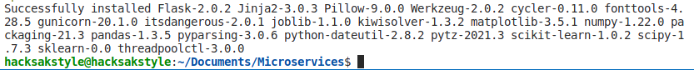

7.Train and save the model. (2 marks)

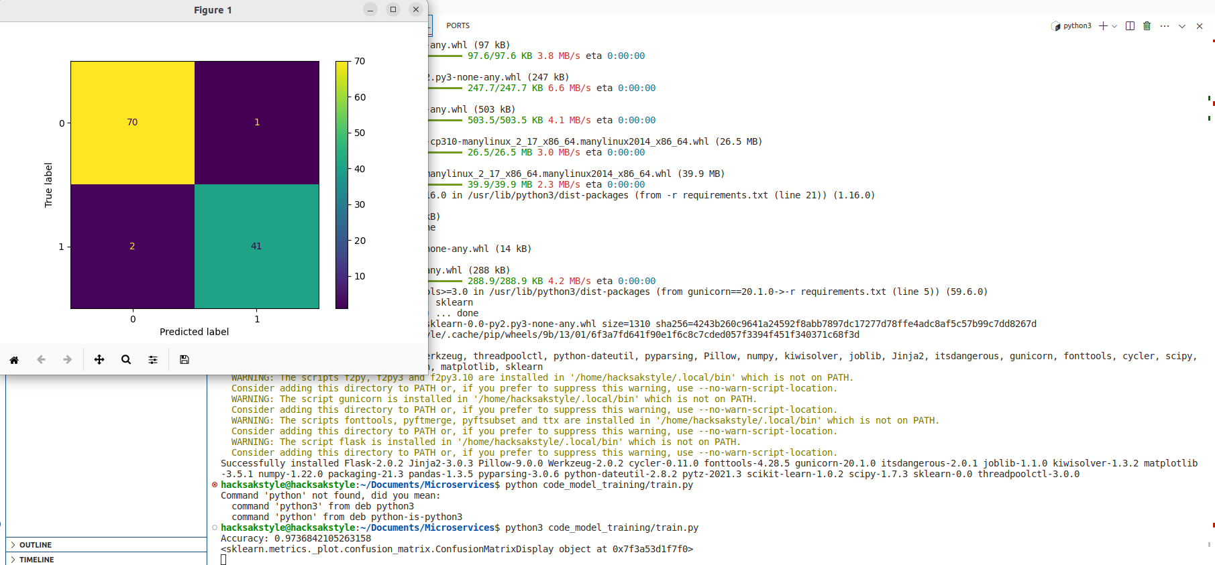

8.Test the Flask web application. (5 marks)

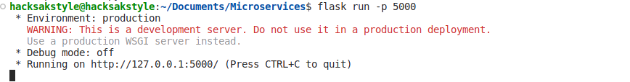

9.Test the application and make predictions using the example calls available in the folder/tests.(5 marks)

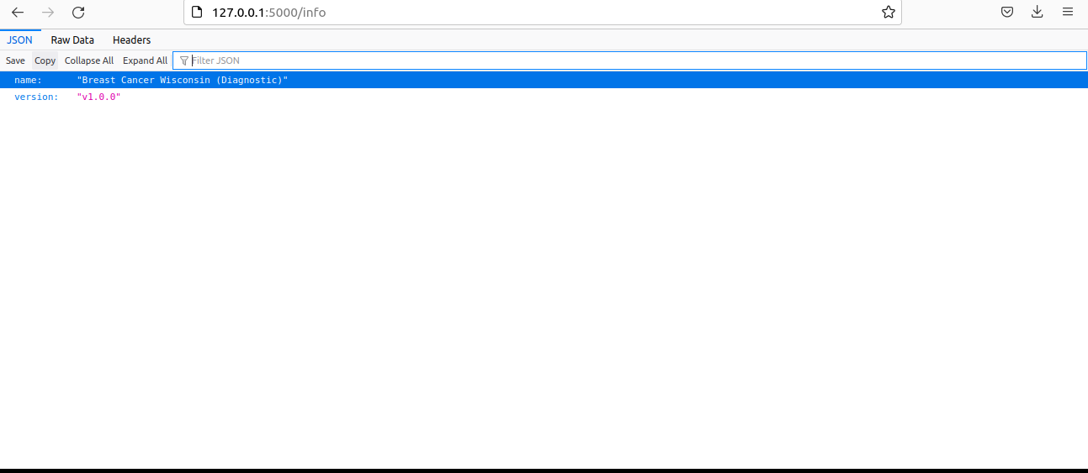

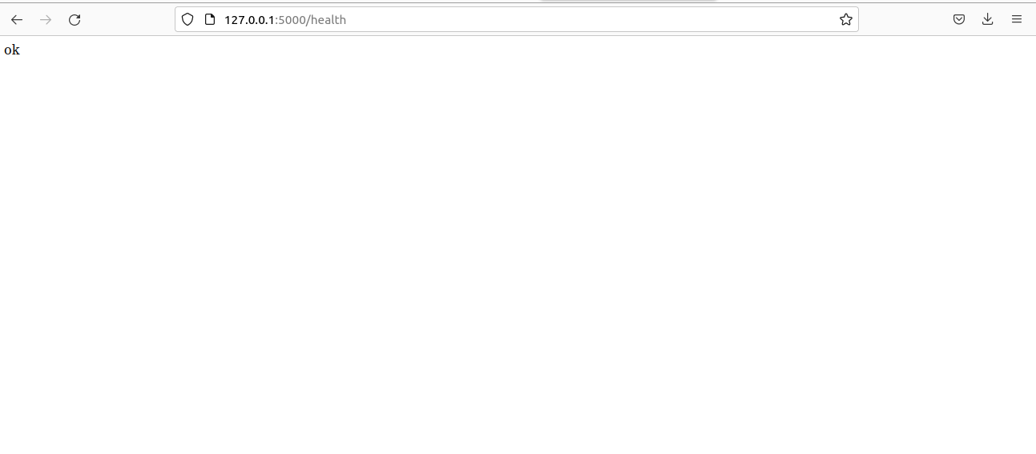

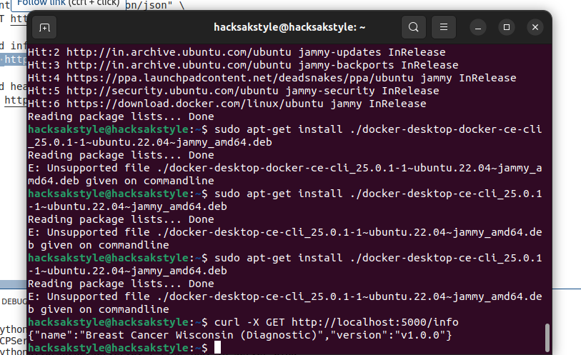

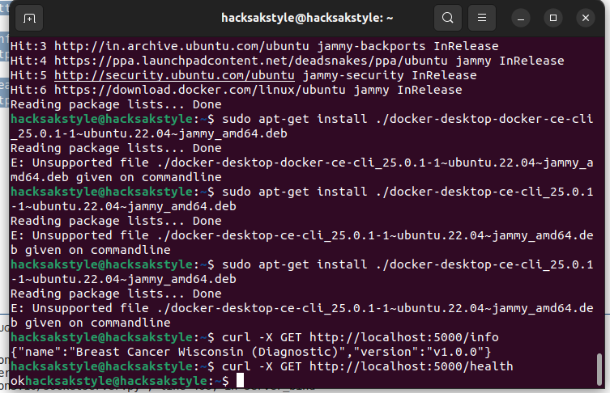

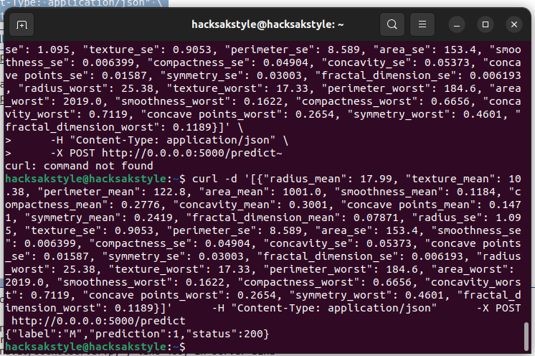

10.Create a docker image containing everything needed to run the application.(10 marks)

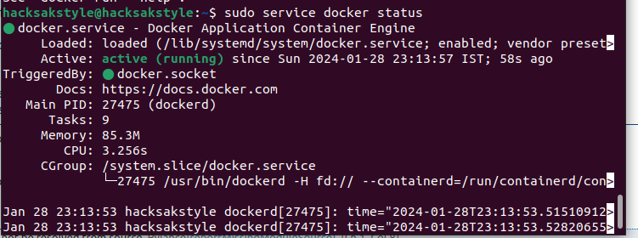

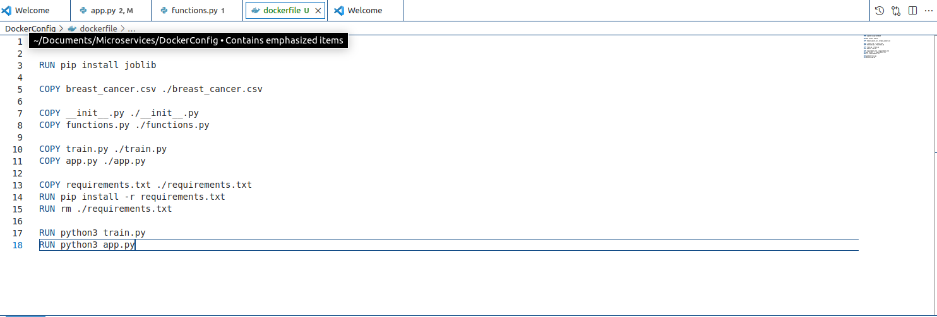

11.Run the containerized application as a prediction service and test it locally by passingsome example calls and get the prediction. (10 marks)

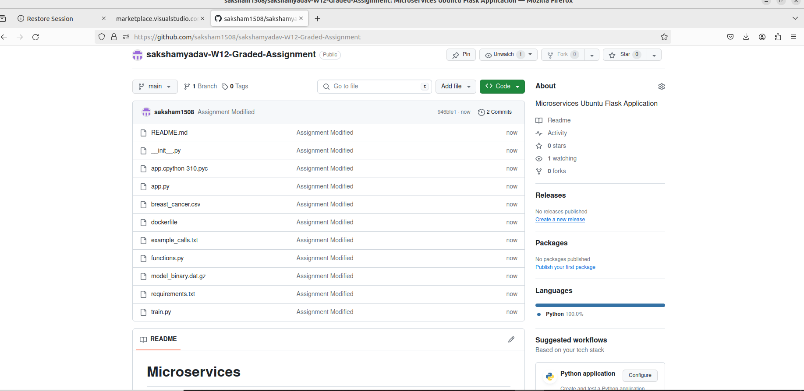

Link to the Repository:

https://github.com/saksham1508/sakshamyadav-W12-Graded-Assignment